深 圳 大 学 实 验 报 告

课程编号： 2801000049

课程名称： 机器学习

实验项目名称： Task 2

学院： 电子与信息工程学院

专业： 电子信息工程

指导教师： 麦晓春

报告人： 古炜 学号：2022280327 班级： 文华班

实验时间： 2024年4月17 至 5月16日

实验报告提交时间： 2024年5月17日

教务部制
1. Experimental Purposes and Requirements
1. Learn Tutorial 6-11.
2. Experiments
✓ Experiment 1: Use logistic regression to implement the classification on the Seeds dataset.
✓ Experiment 2: Use LDA to implement the classification on the Seeds dataset.
✓ Experiment 3: Use KNN to implement the classification on the Seeds dataset.
✓ Experiment 4: Use Naive Bayes classification to implement the classification on the Seeds dataset.
✓ Experiment 5: Use SVM to implement the classification on the Seeds dataset.
✓ Experiment 6: Use decision tree to implement the classification on the Seeds dataset.
3. In each experiment, report the classification results including quantitative results and visualization results.

2. Experiment Contents and Process
2.1 Experiment 1
(1) Experimental Contents/Introduction
- Use logistic regression to implement the classification on the Seeds dataset.
Logistic regression is a generalized linear regression analysis model that belongs to supervised learning in machine learning. Logistic regression mainly solves binary classification problems, commonly referred to as positive and negative classes. The dependent variable describes the probability of a positive outcome. If this probability is equal to or greater than a threshold used to distinguish (usually 0.5), it is predicted as a positive class, otherwise it is predicted as a negative class.

- Experimental process:
Firstly, load the dataset and divide it into feature values and target values. Then, perform linear correlation analysis on the 7 features of the data, draw the correlation matrix, and understand the linear relationship between the features.
Then, the features are normalized and the data is divided into training and testing sets, and logistic regression classification training begins.
For logistic regression, use the LogisticRegression from the sklearn library to implement classification. Firstly, use the LogisticRegression() function to create a Logistic Regression classifier. Next, fit the classifier based on the features of the training set and the target label. Then, predict the label results of the test set based on the classifier. Finally, output the coefficient w values of the 7 features of the logical classifier, calculate the accuracy of the prediction, and draw a confusion matrix to observe the classification results more intuitively.

(2) Methods
Logistic regression is a classification method mainly used for binary classification problems, using logistic functions (i.e. sigmoid functions).
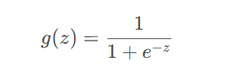
The original conditional probability is (w is the set vector matrix, x is the vector represented by the feature, and b is the bias term)
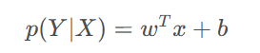
By combining the above two equations, conditional probability and logistic regression can be linked together. Therefore, under the condition of feature X, the probability of being classified into category Y is:
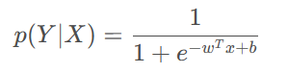
The sigmoid function is shown in the figure:
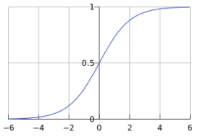
If it is a binary classification, there are:
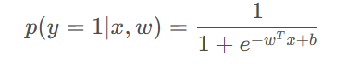
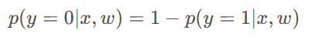
Namely:
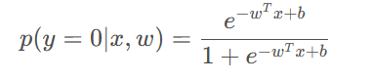
Combining the two equations of y=1 and y=0 yields:
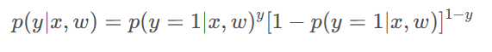
Now we need to maximize the objective function. Identify the w and b that maximize the objective function
Introducing maximum likelihood:
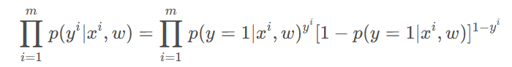
Taking the natural logarithm from both sides yields:
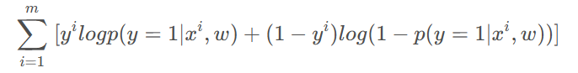
Maximizing the original function is equivalent to finding the minimum function:
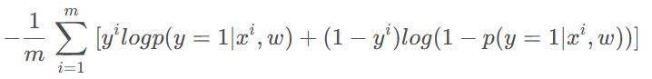
If p (y=1| x^{i}, w) is expressed as h (x^{i}), the final objective function is:
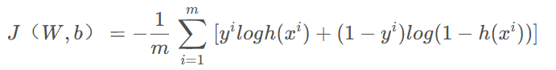

(3) Data Collection, Preprocessing and Analysis
- Correlation matrix:
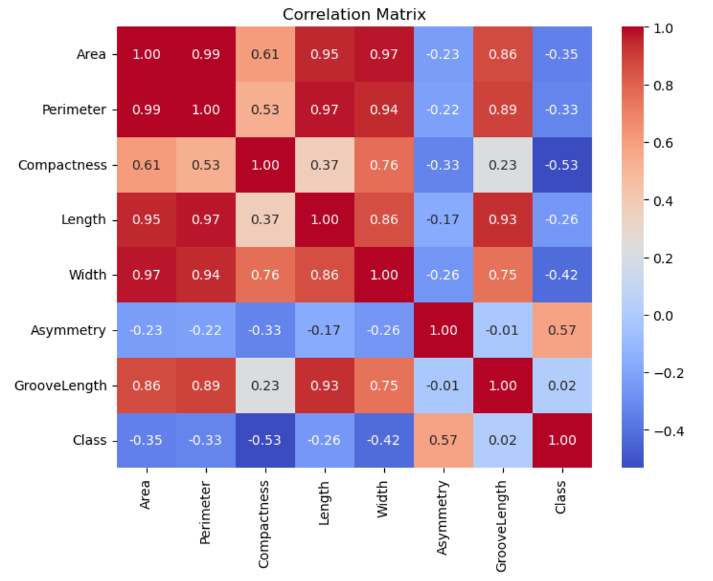

(4) Experimental Results and Analysis
-Logistic Regression Coefficients:
Variable | Coefficient
Area | 0.096
Perimeter | 0.196
Compactness | 0.208
Length | 1.365
Width | -0.038
Asymmetry | -0.868
Groove Length | -1.886

-Classification accuracy on the test set:
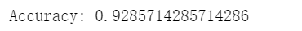

-Confusion Matrix:
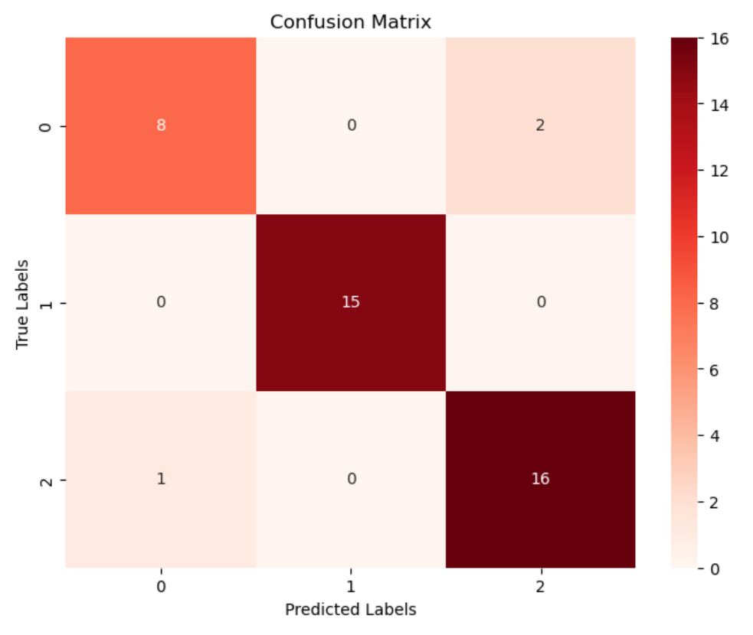

2.2 Experiment 2
(1) Experimental Contents/Introduction
- Use LDA to implement the classification on the Seeds dataset.
Linear Discriminant Analysis (LDA) is a classic supervised learning algorithm mainly used for dimensionality reduction and classification tasks. It is an induction of Fisher's linear discriminant method, attempting to find a linear combination of features of two types of objects or things, in order to characterize or distinguish them. The obtained combination can be used as a linear classifier or for dimensionality reduction in classification. It can map multidimensional data to low dimensional space and preserve category differences between data.

- Experimental process:
For linear discriminant analysis, we use the same data as the logistic regression mentioned above for the dataset. Use LinearDiscriminantAnalysis from the sklearn library to implement classification. Firstly, use the LinearDiscriminantAnalysis() function to Create and train the LDA classifier. Next, fit the classifier based on the features of the training set and the target label. Then, predict the label results of the test set based on the classifier. Finally, output the coefficient w values of the 7 features of the LDA classifier, calculate the accuracy of the prediction, and draw a confusion matrix to observe the classification results more intuitively.

(2) Methods
The idea of LDA is to minimize the intra class variance and maximize the inter class variance after projection.
Let's first define two variables.
Within class dispersion matrix: reflects the degree of dispersion of data within the same category.
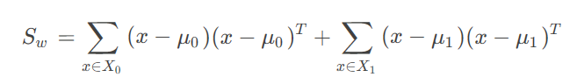
Inter class dispersion matrix: reflects the degree of dispersion of data between different categories.
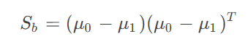
Among them, x_{i}, μ_{i} represents the set and mean vector of examples of class i∈{0,1}, respectively.
Our goal is to make the projection points of similar examples as close as possible, that is, to make S_{w} as small as possible. And to make the projection points of heterogeneous examples as far away as possible, that is, S_{b} should be as large as possible. By considering both simultaneously, the goal of maximizing can be obtained:
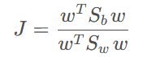
Lagrange multiplier method
We can find that the solution of J is not related to the length of w, but only to the direction of w. Without losing generality, if w^{T}S_{w}w=1, it can be equivalent to calculating the following equation:
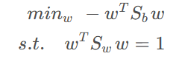
According to the Lagrange multiplier method, the above equation is equivalent to:
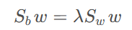
among λ It is a Lagrange multiplier.
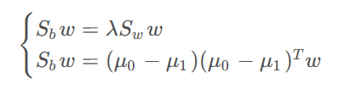
And because (μ₀ − μ₁)^{T}w is a scalar, and because it is only related to direction, it can make (μ₀ − μ₁)^{T}w=C, simultaneous solvable
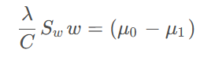
Only related to size, so λ/ C=1, with:
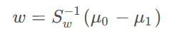

(3) Experimental Results and Analysis
-Logistic Regression Coefficients:
Variable | Coefficient
Area | -31.231
Perimeter | 24.666
Compactness | 5.353
Length | 10.862
Width | -0.913
Asymmetry | -1.075
Groove Length | -8.76

-Classification accuracy on the test set:
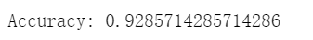

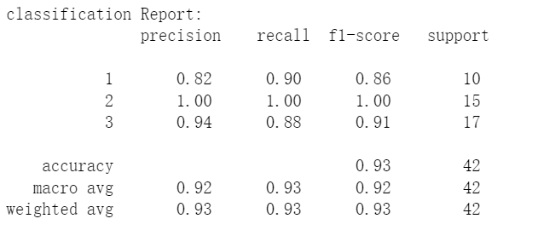

-Confusion Matrix:
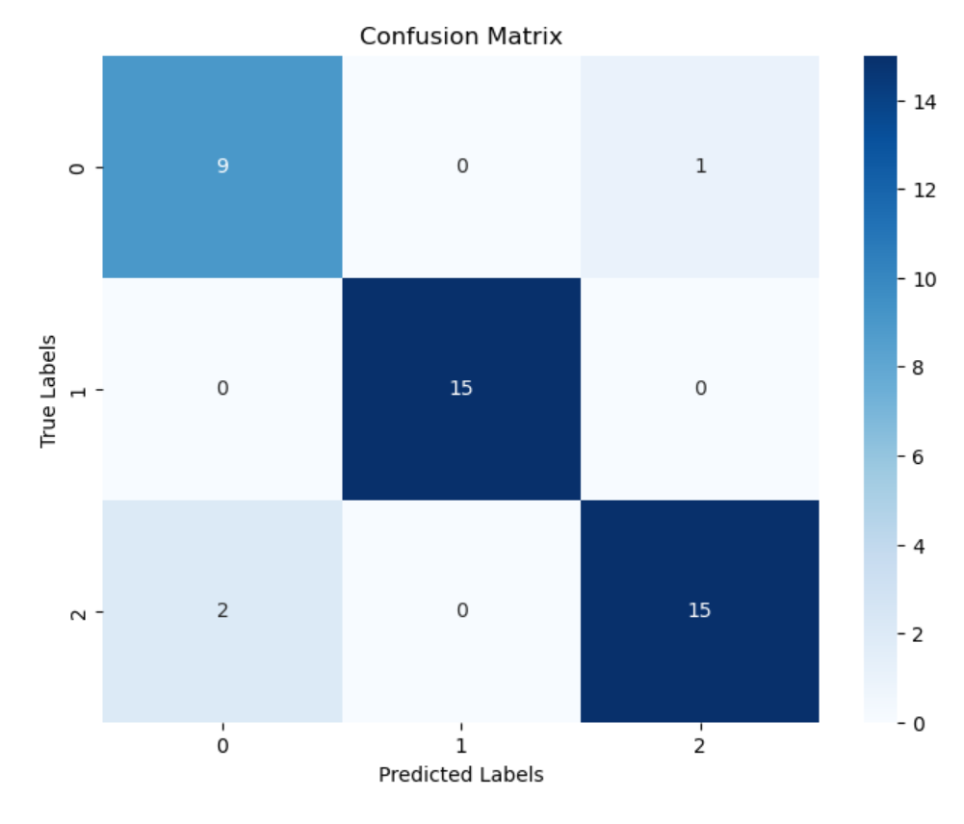

2.3 Experiment 3
(1) Experimental Contents/Introduction
- Use KNN to implement the classification on the Seeds dataset.
KNN algorithm, also known as k-nearest neighbor algorithm, is a classification algorithm in supervised learning. The guiding principle is that "those who are close to the red are red, those who are close to the ink are black", that is, to infer your category from your neighbors. The implementation principle is to determine the category of unknown samples, use all known category samples as references, calculate the distance between unknown samples and all known samples, select the K known samples closest to the unknown samples, and according to the majority voting rule, classify the unknown samples with the K nearest samples that belong to the most category.

- Experimental process:
For KNN, we use the same data as the logistic regression above for the dataset. Use KNighborsClassifier in the sklearn library to implement classification. Firstly, use the KNighborsClassifier() function to Create and train the KNN classifier, where we set the k value to 5. Next, fit the classifier based on the features of the training set and the target label. Then, predict the label results of the test set based on the classifier. Finally, calculate the accuracy of the prediction and draw a confusion matrix to observe the classification results more intuitively.

(2) Methods
The key to KNN algorithm:
- All features of the sample need to be quantitatively comparable
- Sample features need to be normalized
- Need a distance function to calculate the distance between two samples
Minkowski distance:
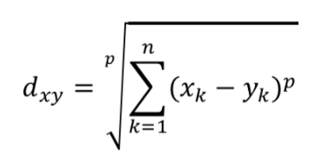
Manhattan distance:
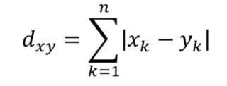
Euclidean distance:
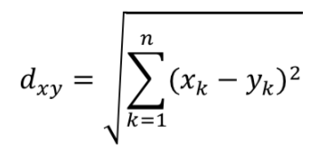
Chebyshev Distance:
Chebyshev distance between two points a (x₁, y₁) and b (x₂, y₂) in a two-dimensional plane:
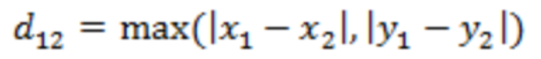
Chebyshev distance between n-dimensional spatial points a (x₁₁, x₁₂, ..., x_{1n}) and b (x₂₁, x₂₂, ..., x_{2n}):
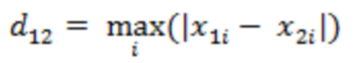
- Selection of k value
Choosing a K value that is too large can lead to underfitting, while choosing a value that is too small can lead to overfitting. Cross validation is needed to determine the K value.

(3) Experimental Results and Analysis
-Classification accuracy on the test set:
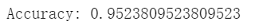
-Confusion Matrix:
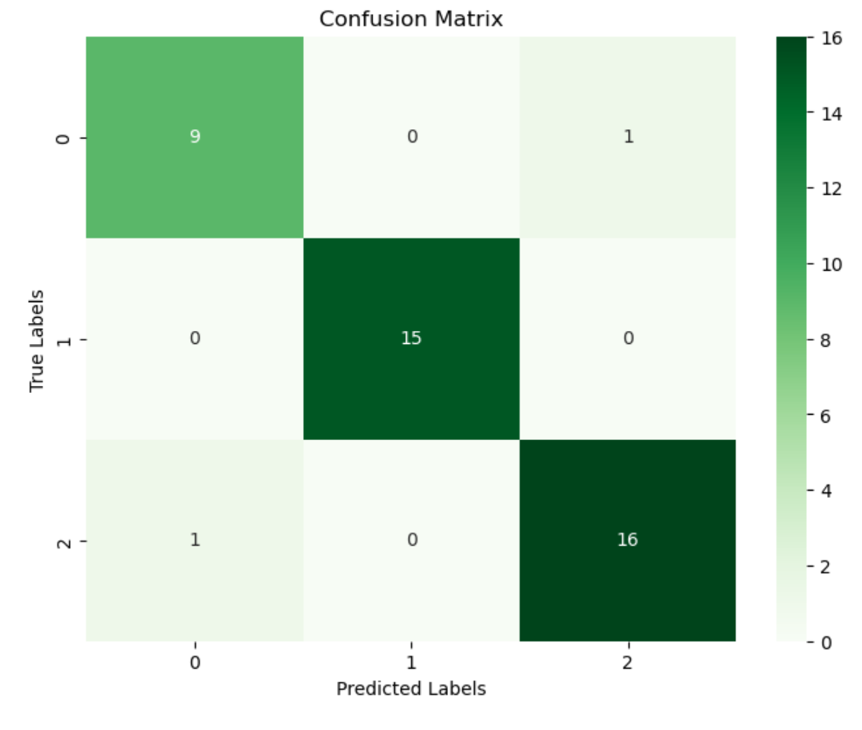
2.4 Experiment 4
(1) Experimental Contents/Introduction
- Use Naive Bayes classification to implement the classification on the Seeds dataset.
Naive Bayes algorithm is a supervised learning algorithm that determines the category of a new sample based on the conditional probability (posterior probability) of its existing features in the dataset. It identifies the sample as the class with the highest posterior probability. It is called "Naive" because it assumes: ①each feature is independent of each other ②Each feature is equally important.

- Experimental process:
For Naive Bayes classification, we use the same data as the logistic regression mentioned above for the dataset. Use GaussianNB from the sklearn library to achieve classification. Firstly, use the GaussianNB() classifier to Create and train the Gaussian Naive Bayes classifier. Next, fit the classifier based on the features of the training set and the target label. Then, predict the label results of the test set based on the classifier. Finally, calculate the accuracy of the prediction and draw a confusion matrix to observe the classification results more intuitively.

(2) Methods
Maximum posterior probability classification criterion:
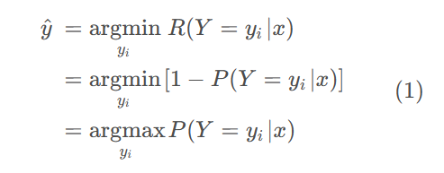
Bayes Rule:
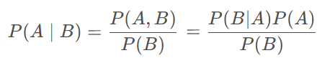
In the classification problem (assuming that the features are discrete), it can be seen as follows:
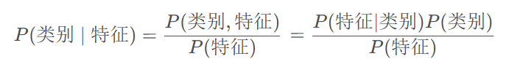
Write the set of categories: Y={y₁, y₂..., y_{n}} and the set of features X={x₁, x₂,..., x_{d}}. Calculate the posterior probability as follows:
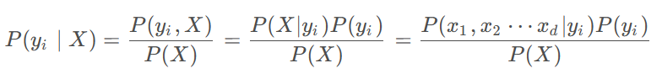
Observe the formula on the far right:
P (x₁, x₂... x_{n} | y_{i}): The joint probability of features in a certain category. If there are many feature combinations, such as each feature x_{i} having two values, there are a total of 2^{d} combinations of features. If there are many features, some combinations in the sample will not appear at all, so it is difficult to calculate
P(y_{i}): The probability of each category in the sample, which can be directly counted as a probability from the sample (the theorem of large numbers).
P(X) is used to calculate the P (y_{i} | X) for each category. We compare the sizes using equation (1), and the same ones do not need to be calculated.
conditional independence assumption:
Naive Bayesian classification makes a strong assumption: assuming that features are independent of each other, the joint probability P (x₁, x₂... x_{n} | y_{i}) can be broken down:
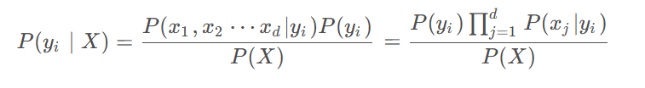

(3) Experimental Results and Analysis
-Classification accuracy on the test set:
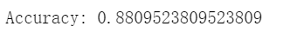
-Confusion Matrix:
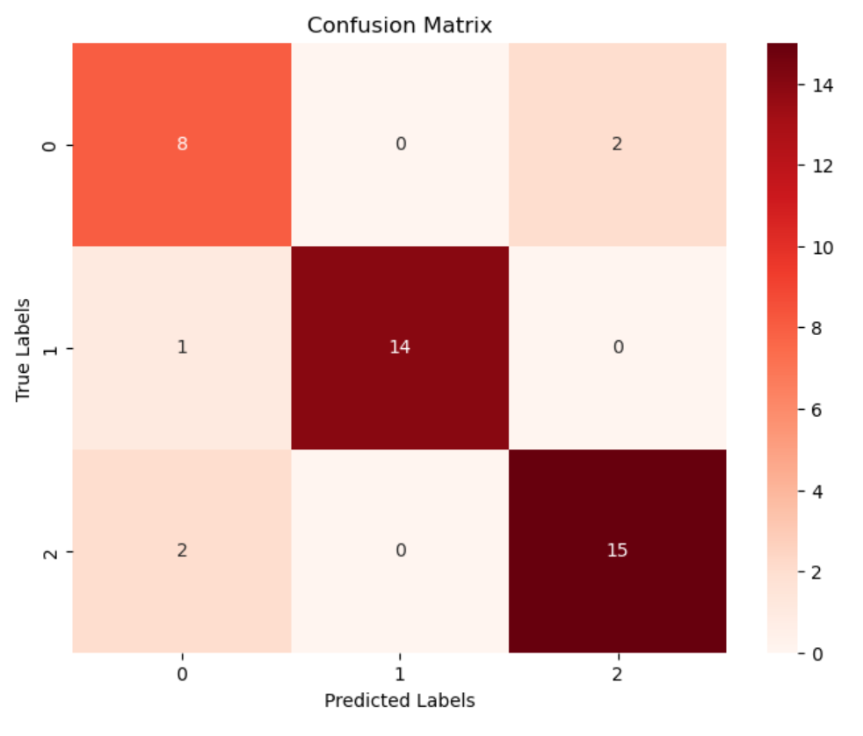

2.5 Experiment 5
(1) Experimental Contents/Introduction
- Use SVM to implement the classification on the Seeds dataset.
Support Vector Machines (SVM) are a binary classification model that maps the feature vectors of instances to points in space. The purpose of SVM is to draw a line to "best" distinguish these two types of points, so that if there are new points in the future, this line can also perform well in classification. SVM is suitable for classification problems involving small and medium-sized data samples, nonlinearity, and high dimensionality.

- Experimental process:
For SVM, we use the same data as the logistic regression mentioned above for the dataset. Use SVC from the sklearn.svm library to implement classification. Firstly, use the SVC() function to Create and train the SVM classifier, where we set a linear kernel function. Next, fit the classifier based on the features of the training set and the target label. Then, predict the label results of the test set based on the classifier. Finally, calculate the accuracy of the prediction and draw a confusion matrix to observe the classification results more intuitively.

(2) Methods
The core idea of SVM is to find a hyperplane that separates sample points of different categories as much as possible and maximizes the gap between the two categories. This hyperplane is called the maximum interval hyperplane and can perform classification prediction well.
- Define input data:
Assuming that the training set on a given feature space is:
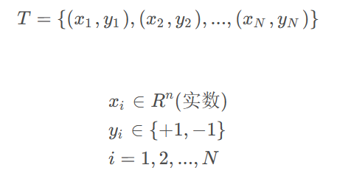
Among them, (x_{i}, y_{i}) is referred to as the sample point.

- Linear Separable Support Vector Machine
Given the linearly separable training dataset proposed above, the separation hyperplane is obtained by maximizing the interval, which is:
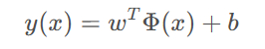
Among them, y(x) represents the distance from sample x to the separation hyperplane.
The corresponding classification decision function is:
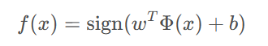
Here's an explanation Φ：
This is a certain deterministic feature space transformation function that maps x to a higher dimension, and it has a proprietary title that we will often see in the future called "Kernel Function".
For example, the features we see have two, namely x1, which forms the first linear function w1x1+w2x2.
But perhaps these two features cannot describe the data well, so we transform the dimensions into a five dimensional feature space, resulting in:
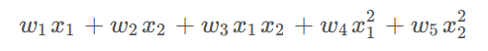
So we added three more features. The above is a general description Φ How is it mapped to x.
Here is an optimal hyperplane:
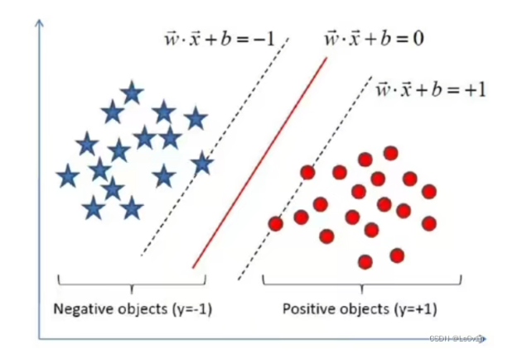

- Derive objective function:
Hyperplane expression:
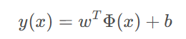
Where y (x) represents the distance from sample x to the separation hyperplane.
For convenience, we let the kernel function not be mapped, i.e Φ (x) =x. So in the sample space, partitioning hyperplanes can be described by the following linear equation:
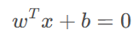
We know:
w= (w₁, w₂, ..., w_{d}) is the normal vector that determines the direction of the hyperplane.
b is the displacement term, which determines the distance between the hyperplane and the origin

Obviously, the partition of hyperplanes can be determined by the normal vector w and displacement b, which we denote as (w, b).
So, the distance from any point x in the sample space to the hyperplane (w, b) can be written as:
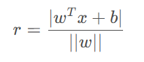
Assuming that the hyperplane (w, b) can correctly classify the training samples, for (x_{i}, y_{i}) ∈D:
①If y_{i}=+1, then w^{T}x_{i}+b>0 ②If y_{i}=−1, then w^{T}x_{i}+b<0
Let:
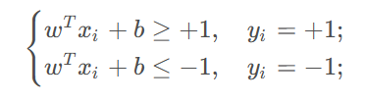
As shown in the figure, the closest training sample points to the hyperplane are called "support vectors" if the above equation holds, and the sum of the distances between the two heterogeneous support vectors and the hyperplane is y=2/||w||, which is called the "interval".
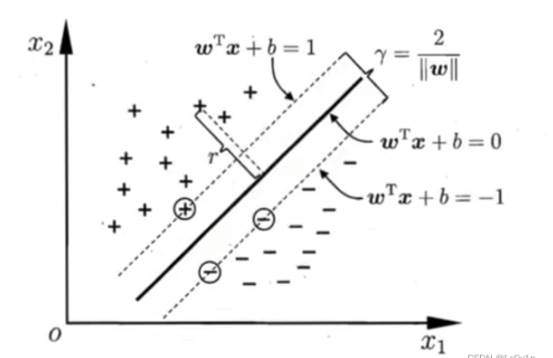
To find a partition hyperplane with the maximum interval, it is necessary to find parameters w and b that satisfy the constraints in the following equation, such that r is maximized.
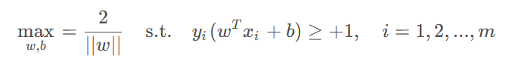
So the meaning of the above equation is: find the maximum value of 2/||w||, so that y_{i}(w^{T}x_{i}+b) ≥1 satisfies. Obviously, in order to maximize the interval, it is only necessary to maximize the value of ||w||⁻¹, which is equivalent to minimizing the value of ||w||⁻². So the above equation can be rewritten as:
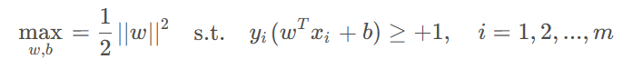
This is the basic form of support vector machines.

- Solving the objective function:
Lagrange multiplier method:
Through the Langrange multiplier method, we can transform the objective function into:
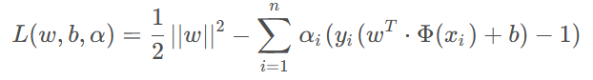
Among them, the latter half of the above equation:
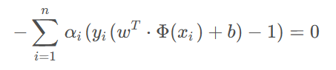
Dual problem:
We need to transform it into a dual problem and transform it into a minimax problem:
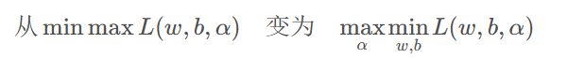
In optimization problems, the dual problem refers to a method of solving the optimal objective function by transforming the original problem. Simply put, the dual problem is to make the solution more efficient and keep the objective function value unchanged. By first eliminating w and b, we can obtain information about α Then calculate the function separately α，Obtained through α Reverse calculation of w, b, and finally obtain the parameters of the hyperplane, compared to first solving for α Using inequality constraints for calculation, the dual approach makes the calculation more convenient.
Firstly, we take the derivatives of w and b for the original objective function:
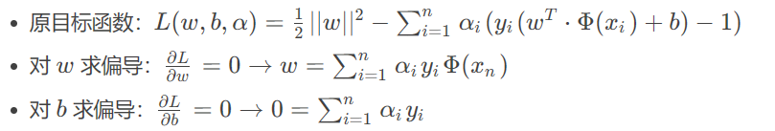
Then, by substituting the derivative functions of w and b into the original objective function w and b, the dual function of the original function is obtained:
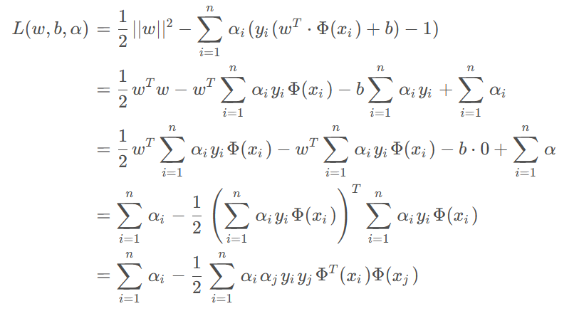
So what is required now is the maximum value max (a) of this function, written as the formula:
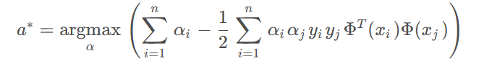
Now we only need to find the maximum value a for the above equation, and then substitute a into the formula for obtaining the partial derivative of w:
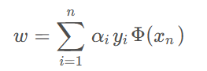
So we can calculate w. Substitute w into the expression of the hyperplane and calculate the value of b. The current w and b are the parameters of the optimal hyperplane we are looking for.

(3) Experimental Results and Analysis
-Classification accuracy on the test set:
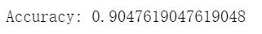
-Confusion Matrix:
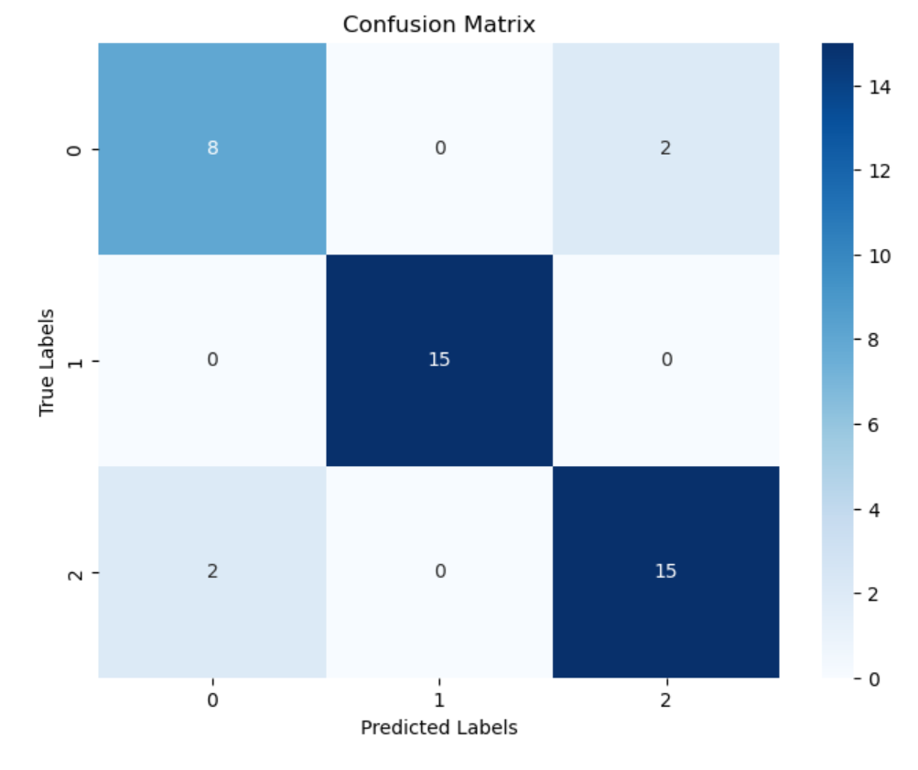
2.6 Experiment 6
(1) Experimental Contents/Introduction
- Use decision tree to implement the classification on the Seeds dataset.
Decision tree is a fundamental classification and regression method. The decision tree model presents a tree like structure, representing the process of classifying instances based on features in classification problems. It can be considered as a set of if then rules, or as a conditional probability distribution defined in the feature space and class space.
A decision tree is a tree structure that describes the classification of instances, where each internal node represents a judgment on an attribute, each branch represents the output of a judgment result, and finally each leaf node represents a classification result. Essentially, it is a tree composed of multiple judgment nodes. The classification decision tree model is a tree structure. A decision tree consists of nodes and directed edges. There are two types of nodes: internal nodes and leaf nodes. Internal nodes represent a feature or attribute, while leaf nodes represent a class.

- Experimental process:
For decision tree classification, we reload the dataset and divide it into a test set and a training set, eliminating the need for feature normalization. Use the DecisionTreeClassifier in the sklearn.tree library to implement classification. Firstly, use the DecisionTreeClassificer() function to Create and train the DecisionTree classifier. Next, fit the classifier based on the features of the training set and the target label. Then, predict the label results of the test set based on the classifier. Finally, calculate the accuracy of the prediction and draw a confusion matrix to observe the classification results more intuitively. Use the plod_tree function to draw the decision tree.

(2) Methods
Decision trees usually have three steps: feature selection, generation of decision trees, and pruning of decision trees.
Feature selection: Select a feature from the training data as the splitting criterion for the current node (different feature selection criteria result in different feature decision tree algorithms).
Decision tree generation: Based on the selected feature evaluation criteria, recursively generate sub nodes from top to bottom until the dataset is indivisible, then stop the decision tree and stop the sound field.
Decision tree pruning: Decision trees are prone to overfitting and require pruning to reduce their structure and size (including pre pruning and post pruning).

The general process of decision trees:
① Collect data: Any method can be used.
② Prepare data: The tree construction algorithm is only used for nominal data, so numerical data must be discretized.
③ Analyze data: Any method can be used, and after the construction of the decision tree is completed, the decision tree graph can be checked to see if it meets expectations.
④ Training algorithm: Construct a data structure for a decision tree.
⑤ Test algorithm: Use experience tree to calculate error rate. When the error rate reaches an acceptable range, this decision tree can be put into use.
⑥ Using algorithms: This step can be applied to any supervised learning algorithm, and using decision trees can better understand the intrinsic meaning of the data.

Classic attribute partitioning methods:
Information gain:(信息增益)
Information entropy is the most commonly used indicator to measure the purity of a sample set. Assuming that the proportion of the k-th class of samples in the current sample set D is pk (K=1, 2, ..., |y|), the information entropy of D is defined as:
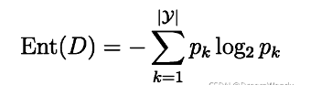
- The smaller the value of Ent (D), the higher the purity of D;
- When calculating information entropy, it is agreed that if p=0, plog2p=0, the minimum value of Ent (D) is 0, and the maximum value is log2|y|;
- When a random variable has only two values, such as 1 and 0, the distribution of X is P(X=1)=p, P(X=0)=1-p, 0<=p<=1. According to entropy, when p=0 or p=1, H(p)=0, the random variable has no uncertainty at all.
- The curve of entropy H(p) changing with probability p is shown in the following figure:
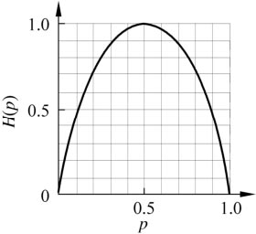
- It can be seen that when p=0 or p=1, H(p)=0, the random variable has no uncertainty at all.

The discrete attribute a has V possible values {a¹, a², ..., a^{v}}. If a is used for partitioning, it will generate V branch nodes, where the v-th branch node contains all samples in D with a value of a^{v} on attribute a, denoted as D^{v}. Then the information gain obtained by dividing the sample set D with attribute a can be calculated:
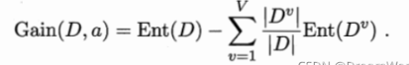
Generally speaking, the greater the information gain, the greater the "purity improvement" obtained by using attribute a for partitioning.

Information gain rate(信息增益率):
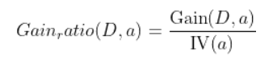
Among:
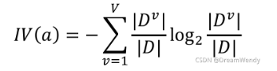
The intrinsic value of attribute a. The more possible values of attribute a (V is larger), the larger the value of IV(a) is usually.

(3) Experimental Results and Analysis
-Classification accuracy on the test set:
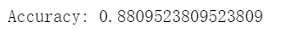
-Confusion Matrix:
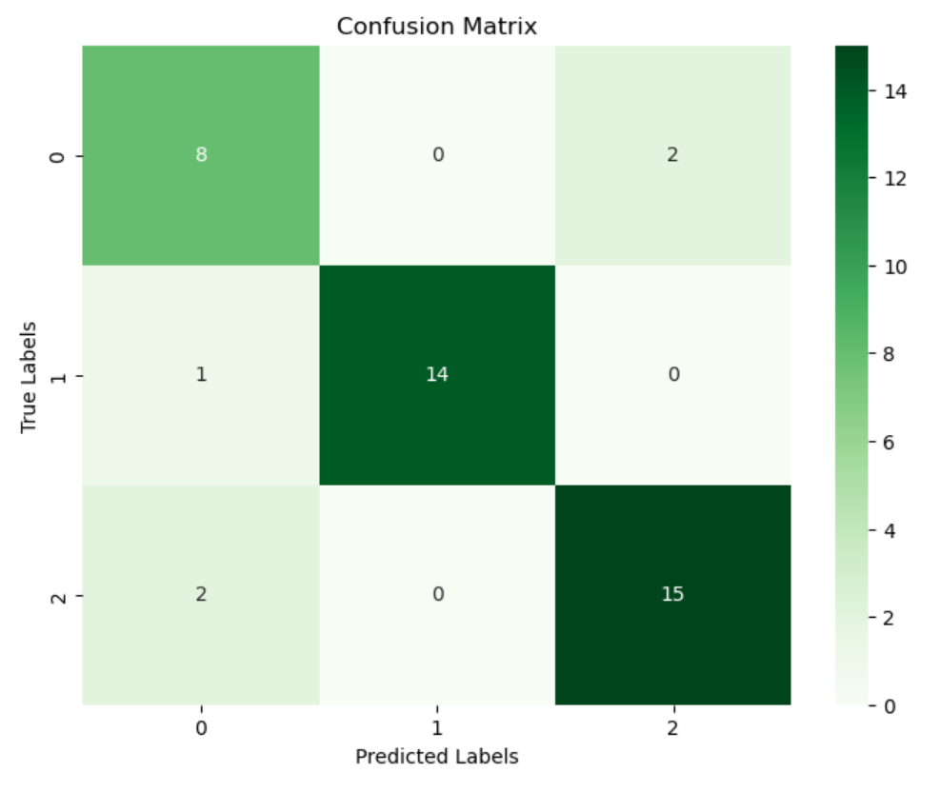
-decision tree:
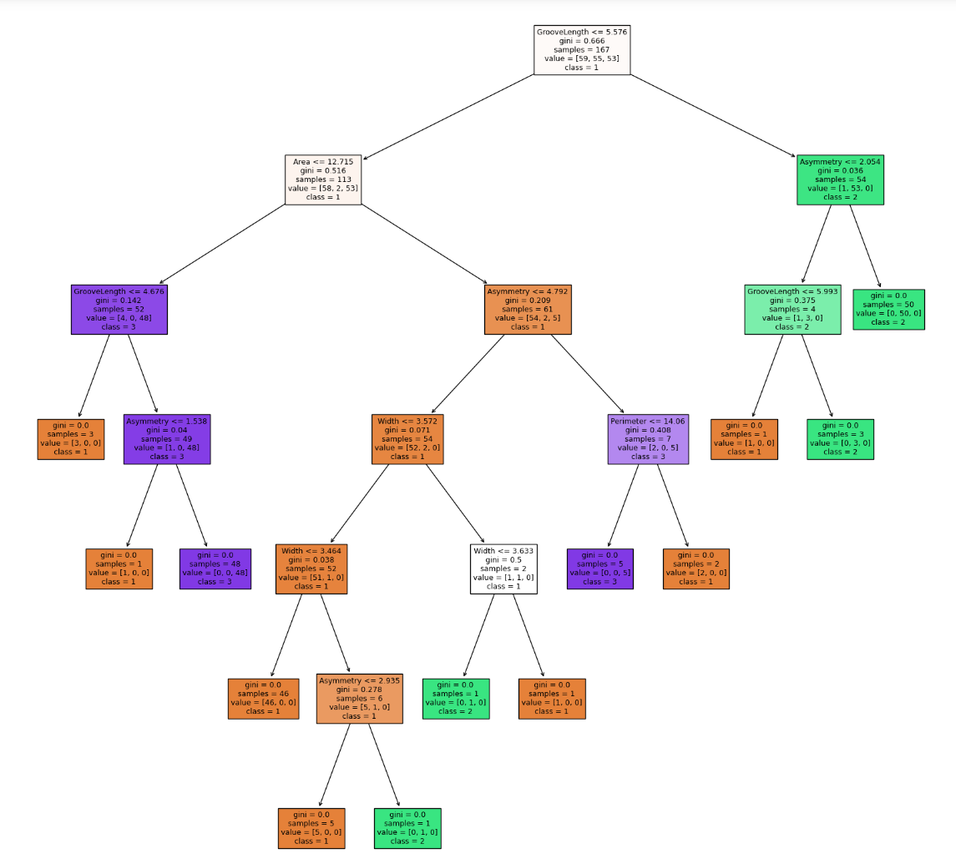
Adding pruning operations to decision trees:
-Classification accuracy on the test set:
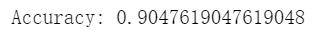
-Confusion Matrix:
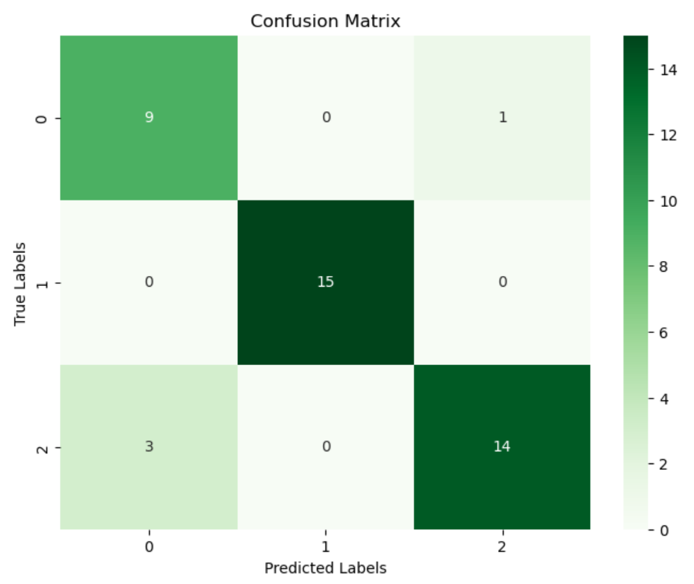
-decision tree:
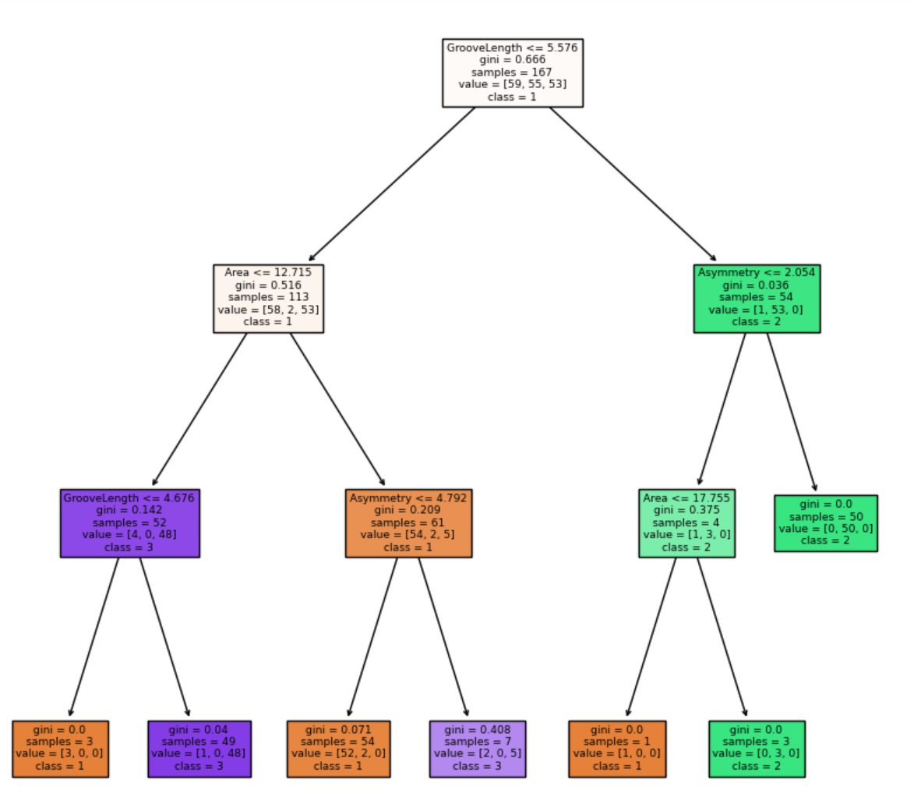

3. Discussion and Conclusions
Through this experiment, we classified the seeds dataset using multiple methods, and the classification accuracy of each method is as follows:
LR | LDA | KNN | Naïve Bayes | SVM | Decision tree
0.929 | 0.929 | 0.953 | 0.881 | 0.905 | 0.881
From the above results, it can be seen that KNN has the highest accuracy, reaching 0.953. This may be because KNN is an instance based learning method, and for small-scale datasets such as Seeds, KNN may be able to better capture the local structure of the data. And the set k value is 5, which can classify more accurately.
Logistic regression and linear discriminant analysis have the same accuracy, both of which are 0.929. Both of these methods are linear models, suitable for simpler classification tasks. Although their accuracy is not as good as KNN, it is still quite impressive.
The accuracy of Support Vector Machine (SVM) is 0.905, slightly lower than KNN and lower than LR and LDA. Although its accuracy is slightly lower on this dataset, SVM is a powerful classifier that typically performs well in handling complex nonlinear problems with strong generalization ability, but requires parameter tuning to achieve optimal performance. The accuracy of SVM on this dataset is relatively low, which may also be due to the unsuitability of the features in the dataset to be modeled using SVM.
The accuracy of Naive Bayes Classification and Decision Tree is both 0.881, which is relatively low. Naive Bayes Classification is a simple and fast classifier, but the assumption of feature independence may limit its performance. However, Decision Tree may overfit when dealing with nonlinear problems, requiring appropriate pruning and other operations. When pruning is added to the decision tree, the accuracy can reach 0.905, which can to some extent enhance the classification effect and avoid overfitting.
Through this experiment, I have deepened my understanding of six classification methods: logistic regression, linear discriminant analysis, KNN nearest neighbor, naive Bayes, support vector machine, and decision tree. I have gained a deeper understanding of their principles and derivation process. Be able to apply these methods to classify practical examples. In addition, I also learned to analyze classification results, such as using confusion matrices to observe classification results more intuitively, and using accuracy to evaluate the quality of classifiers.

指导教师批阅意见：

成绩评定：

指导教师签字：
年 月 日
备注：
注：1、报告内的项目或内容设置，可根据实际情况加以调整和补充。
2、教师批改学生实验报告时间应在学生提交实验报告时间后10日内。

